**Software Engineering CS411**

**Course Project**

Vending Machine Simulator Project

Project Report

Group 5:

Anthony Shuery U35104485

Catherine Quach U77513412

Ruixin Shi U78681604

Xinglin Chen U22151306

**Table of Contents**

**Introduction**

**Problem Definition**

**Problem Objective**

**Stakeholder**

**Success/Acceptance Criteria for Stakeholders**

**Use Case Diagram**

**Selected Use Case Descriptions**

**Sequence Diagram**

**System Architecture**

**Class Diagram**

**State-machine Diagram**

**ER - Diagram**

**GitHub link to Project Source Code**

**Conclusion**

**Reference**

**Appendix**

**Project WBS**

**Task Assignment Matrix**

**Sample of commits on the Selected Version Control System**

**Introduction**

This report is a breakdown of the Vending Machine simulator. This simulator aims to provide users with an easy-to-navigate system that will give them efficient access to the beverage of their choosing. The report goes into detail about the preparation and breakdown of what went into making the simulator, including the use case diagrams, system architecture, and so on.

**Problem Definition**

The problem with Vending machines currently is the lack of interaction between them. If a user cannot find a beverage of their choice, there is no alternative way to get it. They would have to trial and error at the next vending machine. In addition, there is no tracking system on any vending machine or protocol to have their location marked. This is an inefficient system as the user is not able to get their choice of beverage if they are unlucky, and their knowledge of the location of vending machines is either by word of mouth or by memory of stumbling upon one.

Another problem that users tackle is the rejection of wrinkly bills. So, instead if the program has a credit card system and a wallet of some sort, users will be able to buy rechargeable credit for the program. The rechargeable credit can be easily bought at stores with cash.

**Project Objectives**

This simulator is going to tackle the problem definition, and create a program that will have vending machines in one network. If a user wants a beverage from their closest vending machine, they can be redirected to another vending machine in their area.

* **Due Dates listed here - We don’t have anything**

**Stakeholder**

The stakeholders of this program include the owners of the buildings in which the vending machines are being installed, the customers, and the beverage suppliers for the vending machines.

* Owner of the building:

They are the internal stakeholder, as they own the vending machine directly and are in direct relation to the revenue and cost of upholding the system. Their input will be the most valuable to the project, as they are the ones the program will be profiting from.

* Customers:

The customers are important to this project as their feedback on the program will drive the owners, the direct program buyer, to want to fund the program.

* Suppliers:

The suppliers are an external stakeholder to this program, as they will want to be one source in which the vending machines will order resupply stock from.

**Success/Acceptance Criteria**

**Use Case Diagram**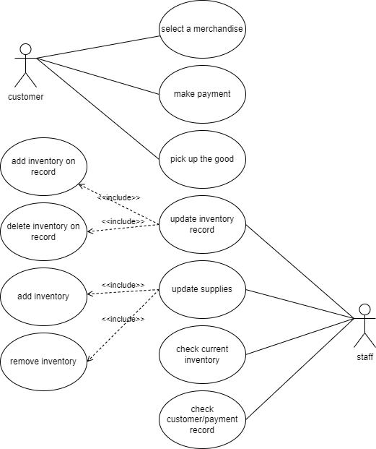

**(needs to be updated)**

**Some ideas for the use case diagram:**

* **We can be more precise and say Select a beverage**
* **(These will have a pointer from select a beverge as an include) Price and locations can be two separate bubbles that the customer can interact with**
* **Make payment can point (as an include) to pick up beverage because w/o paying you don't receive the goods**
* **I think after the payment the system should automatically update the current inventory of the beverage**

**As for the Staff**

* **What's the difference between update supplies and update the record? Is it to differentiate between physically putting in the beverage and then updating the system supplies of the change?**
* **If so, maybe the update supplies point to the updating the inventory record..? Not sure about this point here, just a comment.**
* **Instead of check customer payment record, it's just check income of the current machine since it will be a digitial transaction**

**Use Case Descriptions**

| Use Case Name: | Select Beverage |
| --- | --- |
| Scenario: | Choosing a preferred beverage |
| Triggering Event: | Customer wants to purchase a beverage |
| Brief Description: | When a customer approaches a vending machine and wishes to purchase a beverage. They will be provided with a selection of choices. |
| Actors: | Customer |
| Related Use Cases: | Includes: Price and Alternate Location |
| Stakeholders: | Customer: To provide them with their selection  Suppliers: To provide inventory for the selection of beverages |
| Preconditions: | Customers must exist Inventory items must exist for the provided selection of beverages |
| Postconditions: | Customers’ order will be sent to the machine.  They can be provided with the price of their beverage.  They will be sent to the payment screen. |
| Flow of Activities: | Actor   1. Customer approaches vending machine 2. Customer chooses the beverage of their choosing 3. Customers can access the info of price. 4. Customer is redirected to the payment.   System  1.1. System provides user with a selection of beverages  3.1. System has the information of price ready if the user wants to access it.  5. System provides payment screen |
| Exception Conditions: | 2.1. If the customer chooses a beverage that is out of stock, they can have access to the location of the nearest vending machine with that beverage  3.2 Customers have the option to cancel their order at any point |

| Use Case Name: | Restock Supplies |
| --- | --- |
| Scenario: | Refilling the supplies of the vending machine when it is low |
| Triggering Event: | The supplies of the machine are low, or inventory has arrived. |
| Brief Description: | The staff always has the option to restock the supplies in the vending machine. |
| Actors: | Staff |
| Related Use Cases: | Includes: Updating inventory record |
| Stakeholders: | Customers: They will have a refill of their beverages in the machine  Suppliers: They will receive profit when the machine needs a refill |
| Preconditions: | Customers must be buying drinks from the machine.  The machine must have room for the beverages to be restocked. |
| Postconditions: | The vending machine will have an increase in the stock of the beverage. |
| Flow of Activities: | Staff   1. The staff will open up the machine 2. The staff will refill the machine 3. The machine will update the stock count based on the staffs’ direct instructions |
| Exception Conditions: | 2.1 If the beverage that the staff is trying to refill is already full, then the staff will not be allowed to add any more beverages of that type. |